[Your Company Logo]
Customer Hub Guide

----------------------------------------------------------------------------------------------------------------------------
Note to TeamSupport Customer: This document is intended to be provided to your customer as a guide to using the Customer Hub.
- Please feel free to edit this document as necessary.
- This document lists most of the options that are available on the Hub. If you are not using some of these options, you are able to delete them from this document.
- You may also choose to take screenshots of your own Hub to replace the screenshots in this document.
- Any text in red is meant to be deleted.
----------------------------------------------------------------------------------------------------------------------------

Our Customer Hub is a self service tool that allows us to provide you with exceptional customer support. On the Customer Hub, you will be able to:
- Open new tickets
- View your open/closed tickets
- View open/closed tickets for your organization
- Post Screen Recordings and Video Recordings to tickets
- View Knowledge Base and Wiki Articles
- Engage in a forum called Community
- View your Product information
- Initiate a Chat with one of our Support Representatives

Here are some basic guidelines for using the Customer Hub:

Sign in to Customer Hub

Browse to the login page: [include the URL of your Customer Hub].

Displayed will be any public Knowledge Base and Wiki articles that are available without the need to login.

For a more personalized experience, click ‘Log In’ in the upper right hand corner of the page.

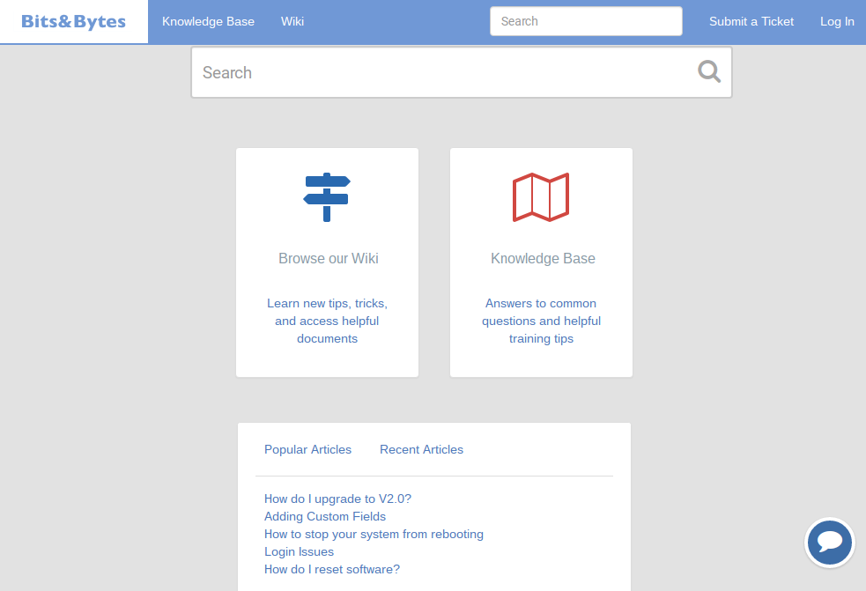

New User

To submit a support request, you will need to setup your account.

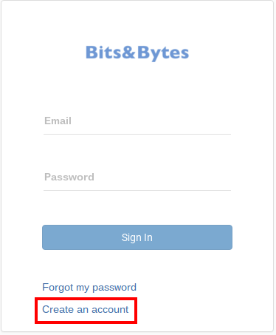

Self Register:

Click the “Create Account” button on the login page. Enter the requested information and click ‘Register Me!’. This will sign you into the Customer Hub with your new account information.

OR Request Access:

Click the ‘Create Account’ button on the login page. Enter the requested information and click ‘Register Me!”. A ticket will be created for this request and a member of our Support Team will contact you soon to provide access to the Hub.

Existing Users

Type in your username and password, then click ‘Sign in’. You will be taken to the Landing Page of the Hub.

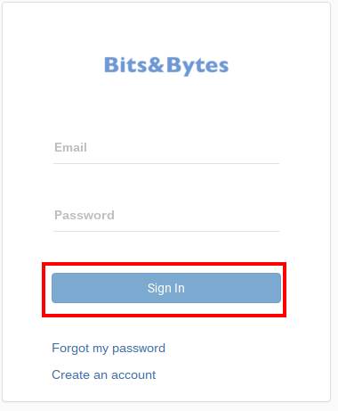

Password Reset

Enter your email address, then the click ‘Forgot my password’ link. A temporary password will be sent to you. Enter this temporary password, and you will then be prompted to create a new password.

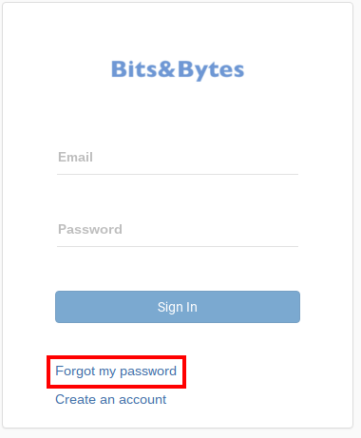

Using the Customer Hub

Landing Page

Once you’re signed into the Hub you will be taken to the landing page which includes recent and popular activity.

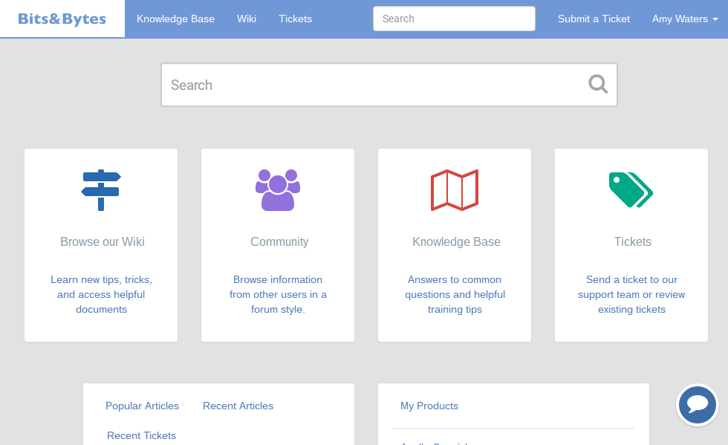

Personal Options

Click on your name in the upper right hand corner of the screen. From here you may view your profile, or Sign Out. Under Profile you can update your Name, Title,
Email Address, and LinkedIn profile URL.

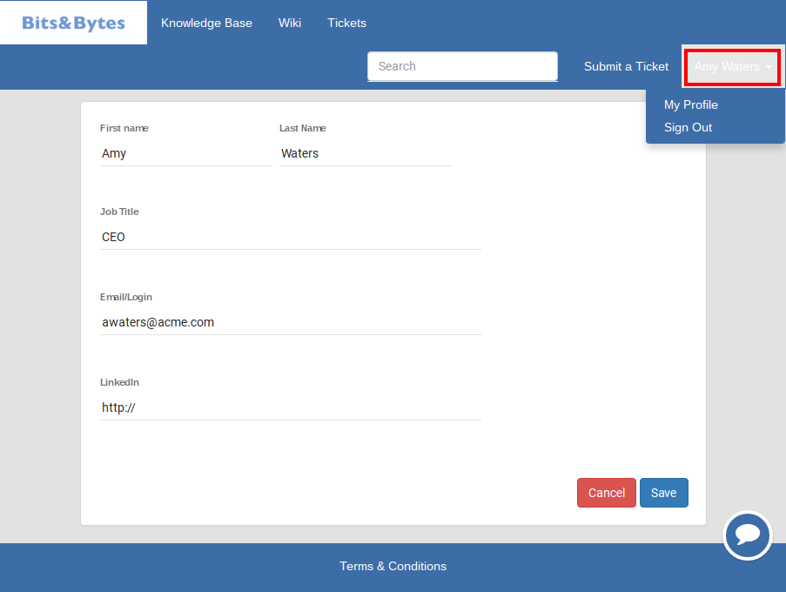

Search

If you know the ticket number for a ticket, or you want to search your tickets for a specific word or phrase you can enter that into a Search Box and click ‘Search’. Depending on which page you are on, you may see more than one Search Box.

Optional: Searching will also return results for Knowledge base articles.

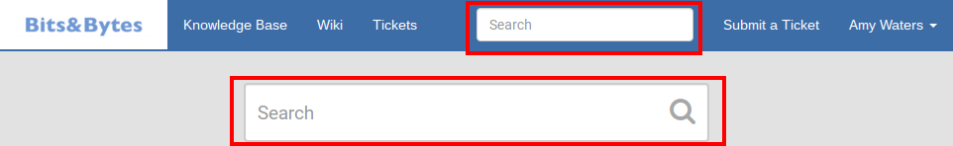

Working with Tickets

Please note that you may always create a ticket by sending an email to: [include your support address here].

From the Dashboard Tickets section you view your Open and Closed Tickets. If you have Manager permissions you can also view tickets for your Organization. You can sort on any of the columns, and you can export your list to a CSV file to view in Excel.

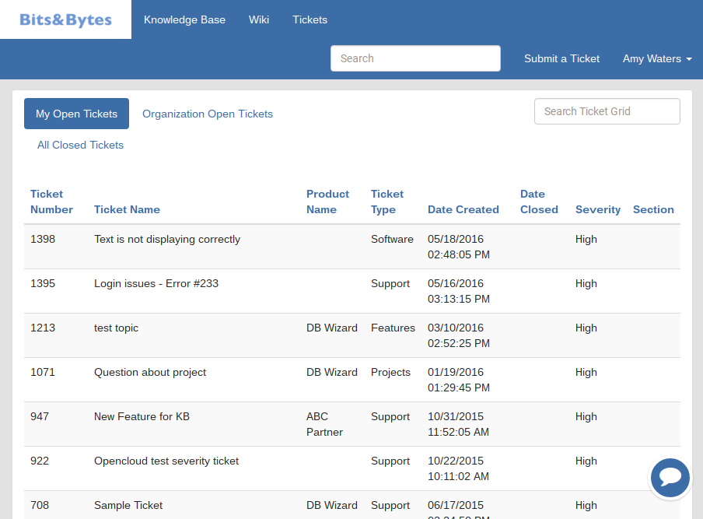

To submit a ticket, select ‘Submit a Ticket’ from the upper right hand corner.

The following form will appear:
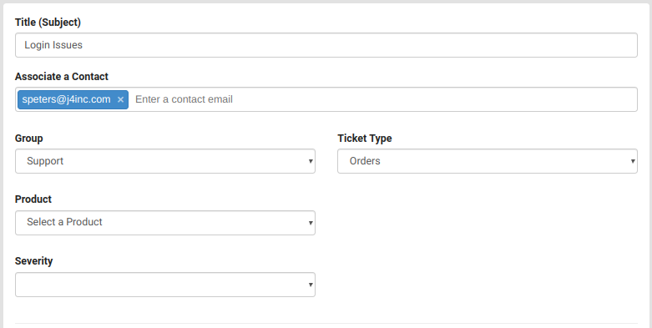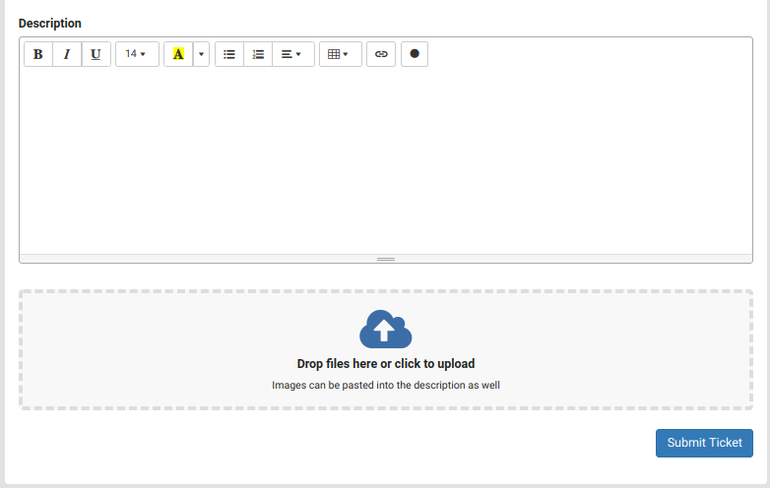

- The Subject field should contain relevant information briefly describing the issue or request.
- To add an additional contact to the ticket, list the email address in the “Associate a Contact” field. Multiple emails can be added separated by commas. All contacts will receive ticket email notifications and will be added as a contact to the ticket.
- The description should contain detailed pertinent information describing the nature of the request, to enable our Support staff to quickly evaluate your request.
- You may add a screen recording to your ticket by clicking the circle “Record” button. This will allow you to record your screen, as well as to optionally narrate with your voice, to show exactly what questions or issues you may have. The recording will be embedded directly in the ticket, and has a maximum of 5 minutes. The first time you use screen recording, you will be prompted to install a browser extension.
- You may also include a video recording to your ticket by clicking the video camera shaped button. This will activate the webcam on your computer and allows you to show a physical product that you need support with. There is a mute button as well if you choose not to narrate with your voice. The first time you use video recording, you will be prompted to install a browser extension.
- To add attachments, just click on ‘Drop files here or click to upload’ button and navigate to the required file and upload it into the ticket. The maximum file attachment size is 25MB per file. You may drag and drop to this space as well, and attach multiple files.
- There may be required fields on this form.

Once you have completed filling out the ticket fields, click ‘Submit Ticket’ and the ticket will be entered into the system. Your new ticket will display on your screen showing the Ticket Details on the left side and the description on the right hand side. You will also receive a confirmation email regarding your ticket submission. The email subject will be the Ticket Name, and the body will contain the body of the ticket.

Once your ticket has been completed to your satisfaction, you can click the ‘close ticket’ button.

Updating a Ticket

Once your ticket has been reviewed and updated by a member of our Support Team, you will receive an email notification. You can update the ticket by replying directly to the email, this will update the ticket without needing to sign into the Hub. Be sure your update is above the ‘--- Please reply above this line ---’ text and the subject of the email is not altered. The ticket number in the subject is used to associate your update with the correct ticket.

To add a new comment to your ticket from the Hub, from the ticket detail window, click ‘New Message’ to display the description box.

While the ticket is open, you may click on the ticket name to update it.

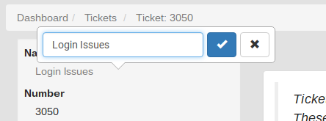

Satisfaction Survey

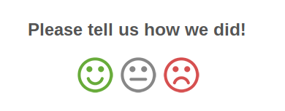

If your ticket is closed by a member of our team, either after you’ve updated it signing off or due to inactivity, you will receive an email notification. At the bottom of the email, you’ll have an opportunity to leave feedback on how you feel your request was handled. Please take a
moment and click on one of the face icons - Happy, Neutral, or Unhappy. A new page will load in your web browser where you can leave an optional comment. We encourage and value your feedback.

Knowledge Base and Wiki

Our Knowledge Base and Wiki sections are meant to provide you with announcements, tips and tricks, new features, usage instructions, and anything else that will be helpful resource to you. The Knowledge Base and Wikis can be found on the Landing Page or on the top navigation. We encourage you to browse or Knowledge Base and Wiki to stay informed and up to date on our offerings.

Community

The Community section is a forum that will allow you to engage with other customers and also our Support staff. You may “Create a Topic” to ask a question to get help from other customers. You may also browse topics to find answers to your questions.
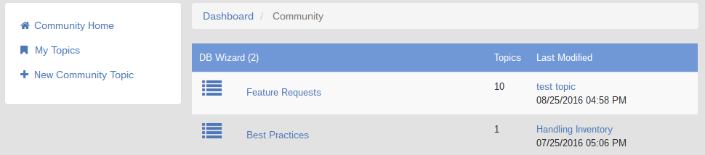

My Products

The My Products section lists all of your products and allows you to see descriptions, current versions, release notes, and gives you the ability to download file attachments. The Products tab can be found on the bottom right hand corner of the Landing Page.

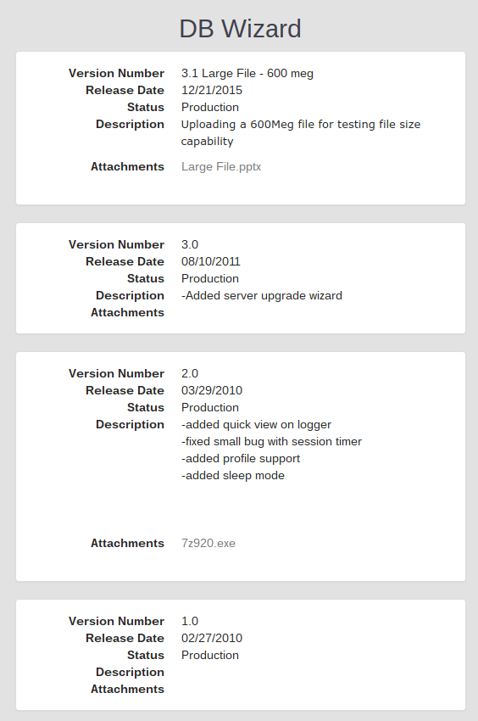

Customer Chat

During business hours we offer Customer Chat, which allows you to initiate a chat with one of our customer support representatives. If a representative is not available, or is unable to answer after 90 seconds, we will make a ticket for your question and will get back with you ASAP via the ticket.

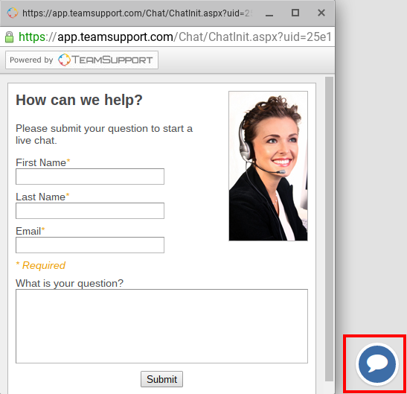

We hope that your experience with your Customer Hub gives you the self service that you require regarding our offerings. Please do not hesitate to reach out to us if you have any questions or issues. We are always available at [enter your telephone number here].

Thank you for using our Customer Hub!

